|  |  |  |
| --- | --- | --- |
| Name: |  |  |

Wellness is a lifestyle in which your body, mind, and spirit are connected. Ideally, wellness is the optimum state of health and well-being that you are capable of achieving. It alsomeans the personal and community qualities that enable you to rebound from adversity, trauma, tragedy, threats, or other stressors — and to go on with life with a sense of mastery, competence, and hope. Wellness includes positive individual traits, such as optimism and good problem-solving skills. To achieve wellness, five life tasks are important. These include *spirituality*, *self-direction*, *work and leisure*, *friendship*, and *love*. As you focus more on wellness and resilience in your lifestyle, please write down what these life tasks mean to you, successes with the life tasks in the past, or your plan for completing each of these life tasks in the future. As you read the life tasks and domains of wellness, reflect upon and write in the open box how you practice these in your life and what goals you have to maintain wellness and resilience principles in the future.

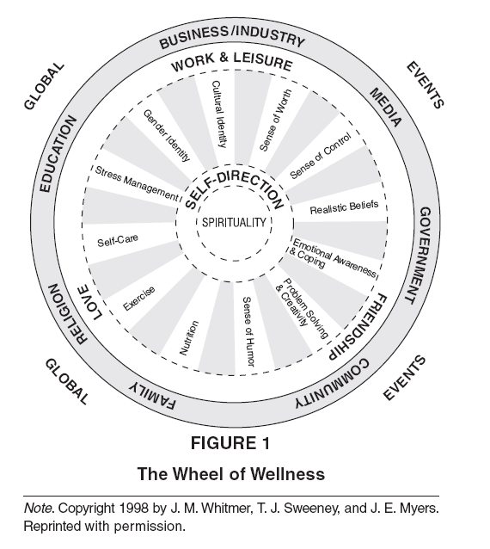

#### Life Task 1: Spirituality

Spirituality is an awareness of being and gives a deep sense of wholeness or connectedness to the universe. Spirituality is not limited to religion or church attendance. Positive thoughts, values, and optimism are components of spirituality; along with a sense of meaning in life. You can measure your level of spirituality by looking at your sense of well-being and experiencing events in a positive manner. Briefly describe your sense of spirituality and goals related to spiritual growth.

|  |
| --- |
|  |

**Life Task 2: Self-Direction**

Self-direction is the manner in which you regulate, discipline, and direct yourself in daily activities and in pursuit of long-range goals. It refers to a sense of awareness and commitment in meeting the major tasks of life. You can measure your self-direction by reviewing the following 11 items.

*Sense of worth* (Accepting who and what you are, positive qualities along with imperfections; valuing yourself as a unique individual)

|  |
| --- |
|  |

*Sense of control* (Belief that you can usually achieve the goals you set for yourself; having a sense of planning in life; being assertive in expressing your needs)

|  |
| --- |
|  |

*Realistic beliefs* (Understanding that perfection and being loved by everyone are impossible goals and having the courage to be imperfect; the ability to see things the way they are)

|  |
| --- |
|  |

*Emotional awareness and coping* (Being aware of or in touch with your feelings; being able to experience and express your feelings appropriately, both positive and negative; including joy, hope, love, gratitude, anger, fear, loneliness, and guilt)

|  |
| --- |
|  |

*Problem solving and creativity* (Making a unique place among others in your social interactions; your ability to find new ways of doing things)

|  |
| --- |
|  |

*Sense of humor* (Being able to laugh at your own mistakes and the unexpected things that happen; the ability to use humor to accomplish even serious tasks)

|  |
| --- |
|  |

*Nutrition* (Eating a nutritionally balanced diet, maintaining a normal weight, and avoiding over-eating and under-eating)

|  |
| --- |
|  |

*Exercise* (Engaging in sufficient physical activity to keep in good physical condition; maintaining flexibility through stretching and muscle relaxation activities)

|  |
| --- |
|  |

*Self-care* (Taking responsibility for your health through physical and dental self-care; practicing safety habits that are preventive in nature; minimizing the harmful effects of pollution in your environment)

|  |
| --- |
|  |

*Stress management* (General perception of your own self-management or self-regulation; seeing change as an opportunity for growth; ongoing self-monitoring and assessment of your mental and emotional coping resources)

|  |
| --- |
|  |

*Gender and sexual identity* (Satisfaction with your gender; feeling supported in your gender; enjoying the masculine or feminine parts of yourself; embracing your sense of sexuality)

|  |
| --- |
|  |

*Cultural identity* (Racial, family, religious, or ethnic traditions; satisfaction with your cultural identity; feeling supported in your cultural identity)

|  |
| --- |
|  |

**Life Task 3: Work and Leisure**

Work (employment or homemaking) and leisure provide an opportunity for pleasurable experiences that are satisfying and provide a sense of accomplishment. They challenge or engage your senses, skills, and interests. Excitement and joy are enhanced while anxiety and boredom are minimized. Write down details of your work and leisure activities.

*Work* (Being satisfied with your work or homemaking; having adequate financial security; feeling that your skills are used appropriately; the ability to cope with workplace or homemaking stress)

|  |
| --- |
|  |

*Leisure* (Activities done in your free time; satisfaction with your leisure activities; having at least one activity in which “I lose myself and time stands still”)

|  |
| --- |
|  |

**Life Task 4: Friendship**

Friendships enhance self-esteem. The friendship life task incorporates all of your social relationships that involve a connection with others, either individually or in community, but do not have a marital, sexual, or familial commitment. People with satisfying social relationships are more likely to avoid health damaging behaviors, such as smoking, drinking, and not using seat belts, and are more likely to consume a nutritious and healthy diet. Write down details of your plan to enhance friendships in whom you can trust and whom can provide emotional, material, or informational support when needed.

|  |
| --- |
|  |

**Life Task 5: Love**

The feeling of being loved and valued by others is the core component of social support. For men, women, and children, committed relationships promote better physical and emotional responses to stress. The life task of love necessitates having a family or family-like support system that has the following nine characteristics: shared coping and problem-solving skills; commitment to the family; good communication; encouragement of individuals; expression of appreciation; shared religious/spiritual orientation; social connectedness; clear roles; and shared interests, values, and time. Briefly describe your plan to promote these characteristics of loving family and social support systems.

|  |
| --- |
|  |